Getting Started with NodeMCU using Arduino IDE

Introduction

NodeMCU is Lua based firmware of ESP8266. There is another way of developing NodeMCU with a well-known IDE i.e. Arduino IDE. We can also develop NodeMCU applications using Arduino development environment. This makes things easy for Arduino developers than learning new language and IDE for NodeMCU.

Let’s see about setting up Arduino IDE with NodeMCU.

First **Download Arduino IDE (version 1.6+)** <https://www.arduino.cc/en/Main/Software>

* **Open Arduino IDE** and **Go to File -> Preference**.

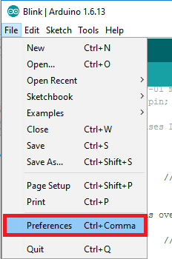

* Now on Preference window, **Enter below link in Additional Boards Manager URLs**

<http://arduino.esp8266.com/stable/package_esp8266com_index.json>

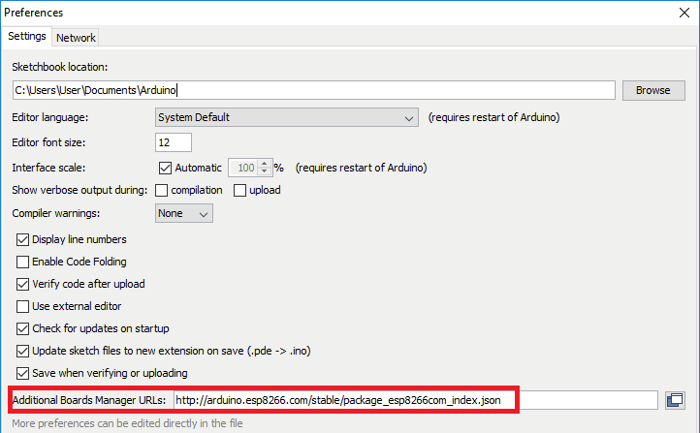

* Now close Preference window and **go to Tools -> Board -> Boards Manager**

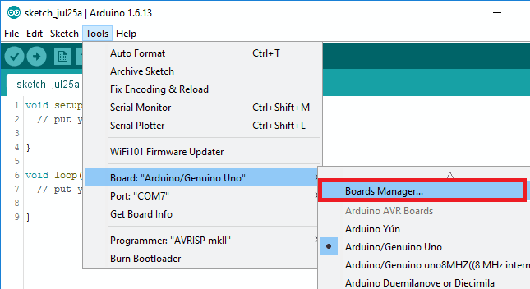

* In Boards Manager window, **Type esp in the search box, esp8266 will be listed there below. Now select latest version of board and click on install.**

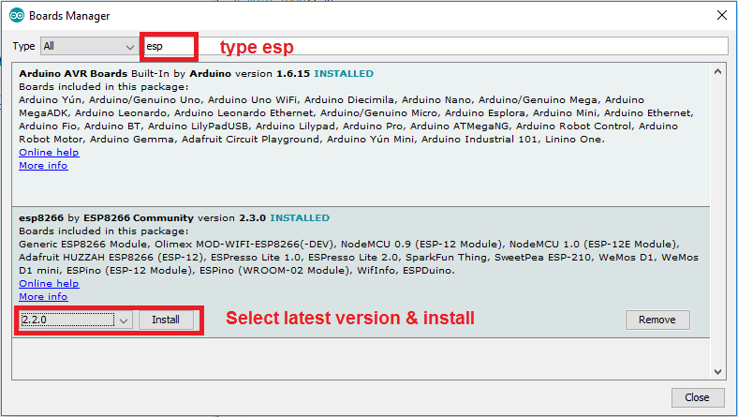

* After installation of the board is complete, **open Tools->Board->and select NodeMCU 1.0(ESP-12E Module).**

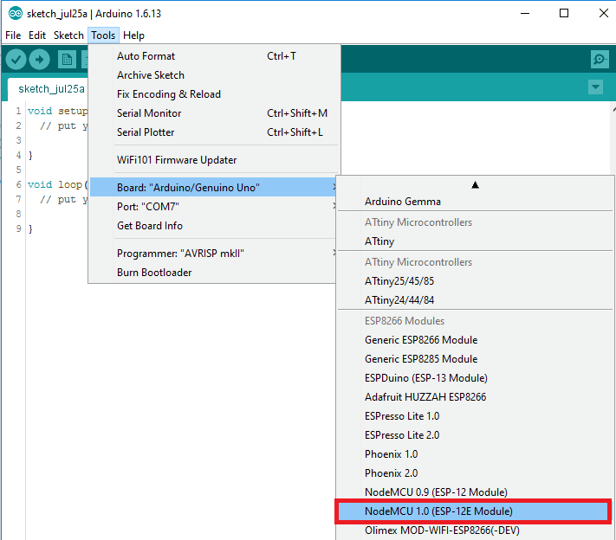

* **Now Your Arduino IDE is ready for NodeMCU**

Example

Let’s see how to write simple serial print sketch using Arduino IDE for NodeMCU.

First connect NodeMCU Development Kit with PC as shown in below figure.

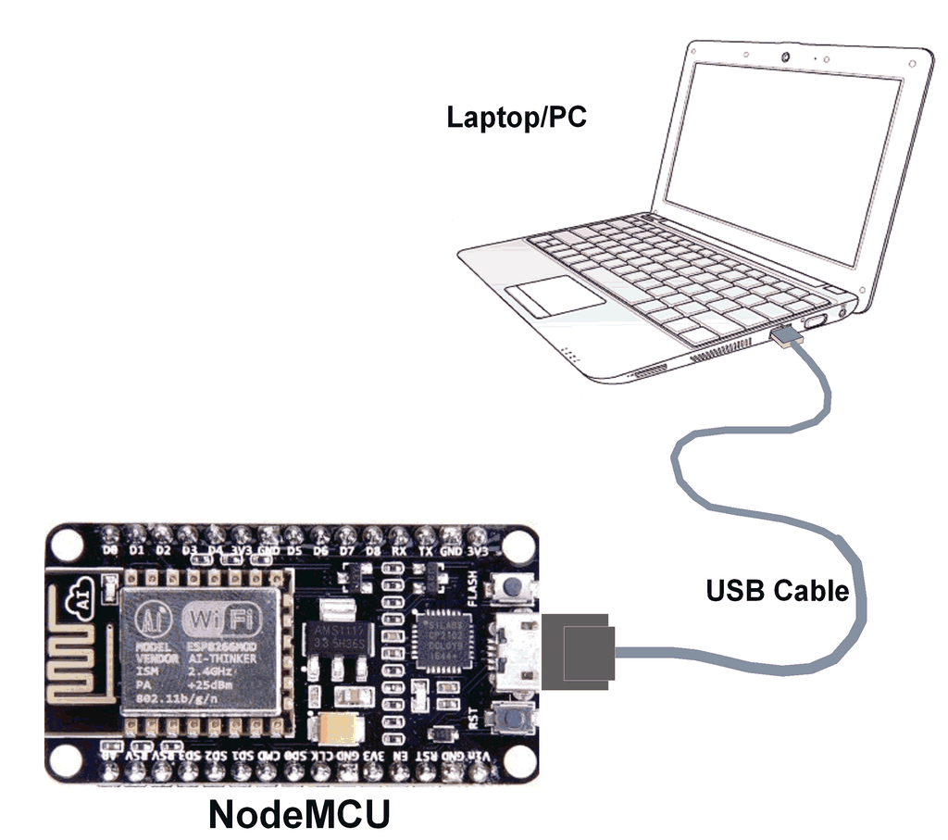

**NodeMCU connection with PC**

* After setting up Arduino IDE for NodeMCU, **open Arduino IDE and write simple sketch of serial print** as shown in below figure.

Arduino Sketch

void setup()

{

Serial.begin(9600); /* initialise serial communication */

}

void loop()

{

Serial.println("JAIN UNIVERSITY"); /* print JAIN UNIVERSITY at new line per second */

delay(1000);

}

* **Ensure that you have selected the correct board** as shown in below figure. Also **make sure that you have selected the appropriate COM port**.

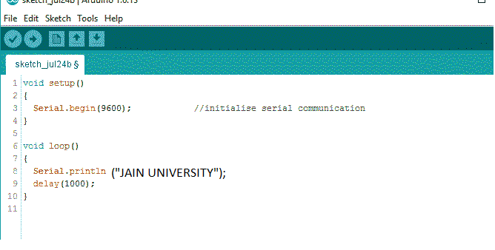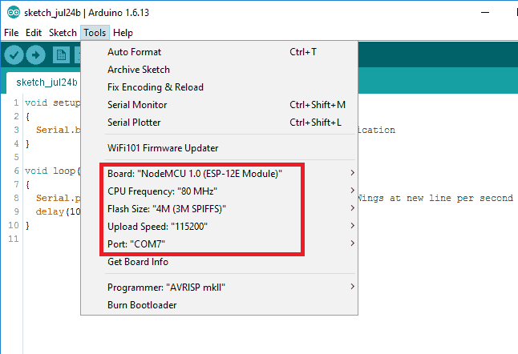

* Now **compile & upload the written sketch** directly to the NodeMCU Dev Kit by clicking on upload button.

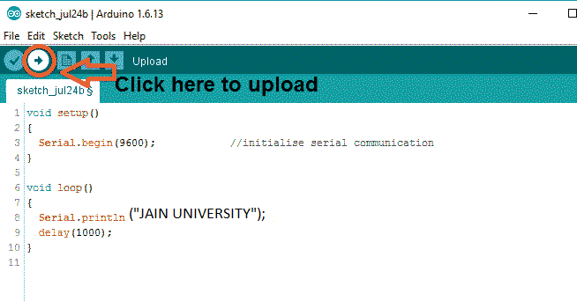

* Now **Click on Serial Monitor (upper right corner) option** to check output on serial monitor window of Arduino IDE.

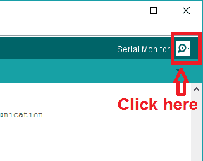

* Serial monitor output window will pop up with output as shown in below figure.
* 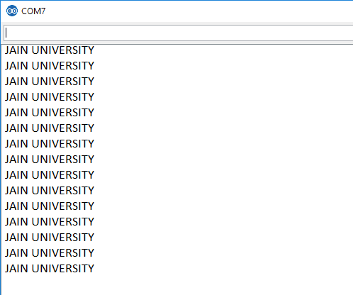

REGARDS:

NARSIMHA REDDY

DHEERAJ T

RAGASRI YARLAGADDA